VALUE ADDED PROBLEM 2:
Problem 2: Given a string s, composed of different combina ons of '(' , ')', '{', '}', '[', ']'. Determine whether the Expression is balanced or not. An expression is balanced if: 1. Each opening bracket has a corresponding closing bracket of the same type. 2. Opening brackets must be closed in the correct order. Concept: Stack
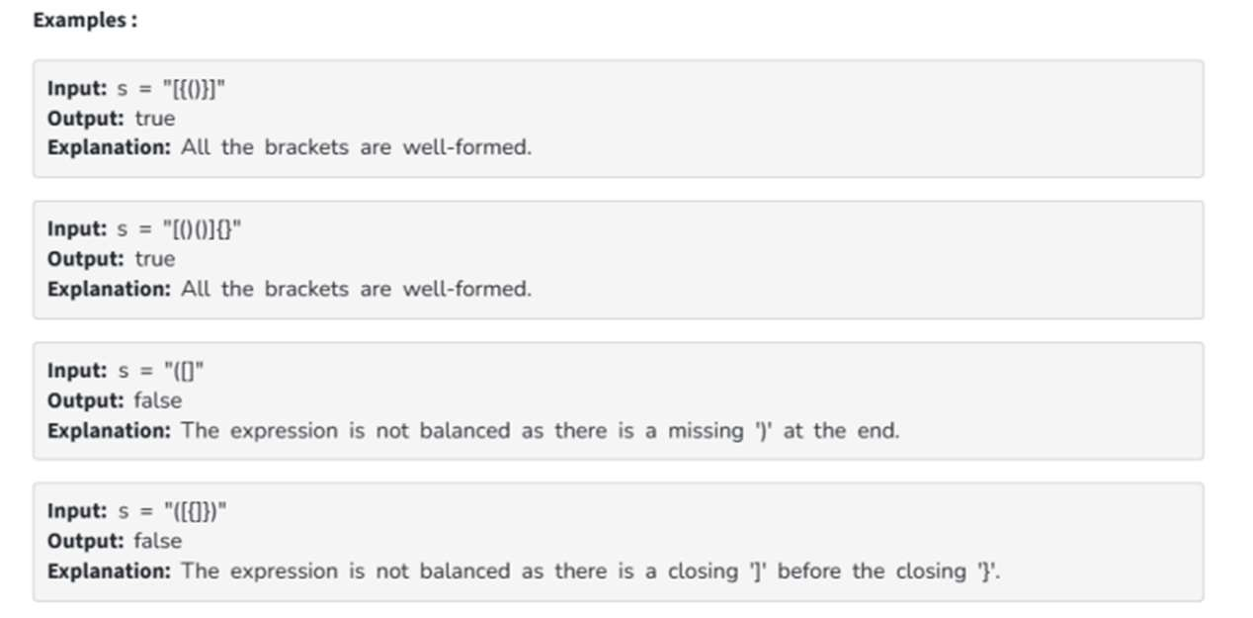
#include <stdio.h>
#include <string.h>
#include <stdbool.h>

#define MAX 1000000

char stack[MAX];
int top = -1;

// Push function
void push(char c) {
stack[++top] = c;
}

// Pop function
char pop() {
if (top == -1) return '\0';
return stack[top--];
}

// Check if stack is empty
bool isEmpty() {
return top == -1;
}

// Check matching brackets
bool isMatch(char open, char close) {
return (open == '(' && close == ')') ||
(open == '{' && close == '}') ||
(open == '[' && close == ']');
}

// Check balanced expression
bool isBalanced(char* s) {
top = -1;

for (int i = 0; s[i] != '\0'; i++) {
char ch = s[i];

// Opening bracket
if (ch == '(' || ch == '{' || ch == '[') {
push(ch);
}
// Closing bracket
else if (ch == ')' || ch == '}' || ch == ']') {
if (isEmpty()) return false;

char top_char = pop();

if (!isMatch(top_char, ch))
return false;
}
}

return isEmpty();
}

// Main function
int main() {

printf("KANHAIYA TYAGI, 25070521157 , SECTION C(2)\n\n");

char* tests[] = {"[{()}]", "[()(){}", "([)", "[{()})"};
int n = 4;

for (int i = 0; i < n; i++) {
printf("Input: \"%s\"\n", tests[i]);
printf("Output: %s\n\n", isBalanced(tests[i]) ? "true" : "false");
}

return 0;
}
